

SIMATS ENGINEERING

Saveetha Institute of Medical and Technical Sciences
Chennai- 602105

Student Name: Vaishali .M Reg. No.:192524440
Course Code: CSA0764 Slot: A
Course Name : COMPUTER NETWORKS FOR A GAME SERVER
Course Faculty: Dr. k. Senthil & Dr. p. Rajaram
Project Title: SECURE DATA COMMUNICATION IN WIRELESS LANS USING TRANSPORT
LAYER SECURITY (TLS)
Module Photographs: (3 photographs –Module Photo, Individual student contribution module work in the project and presentation image)
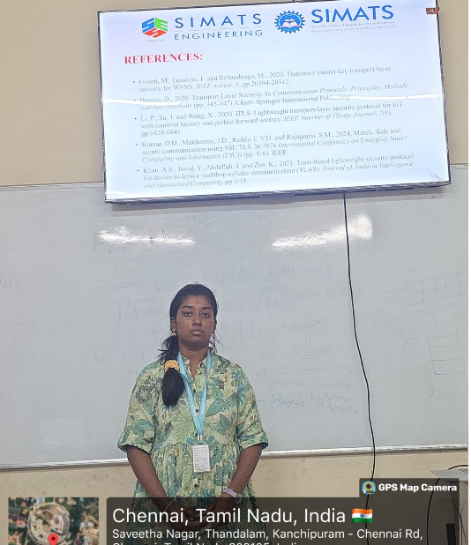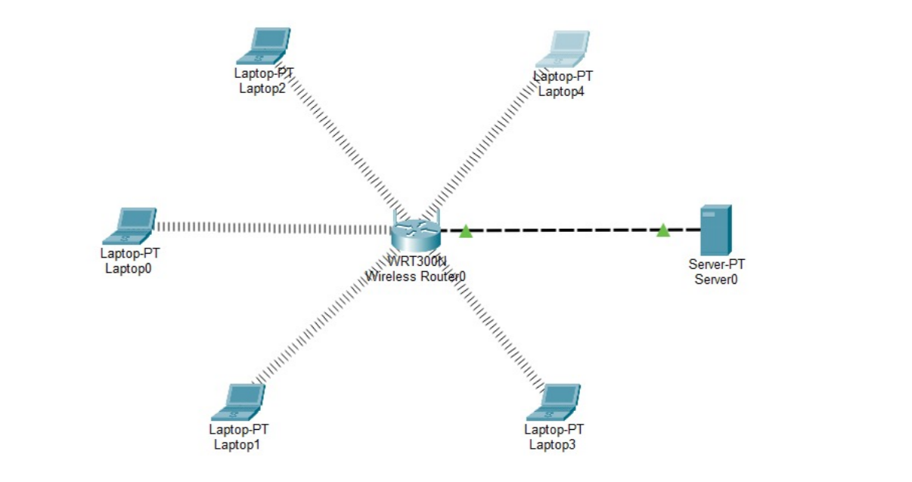
Project Description: (here you write what you did in this project (contribution) including Model Description
Wireless Local Area Networks (WLANs) have become an integral part of modern communication systems, enabling mobility, flexibility, and ease of access. However, the open nature of wireless transmission exposes data to significant security threats such as eavesdropping, unauthorized access, and data tampering. To address these vulnerabilities, Transport Layer Security (TLS) provides a robust cryptographic framework that ensures confidentiality, integrity, and authentication during data exchange.
This project focuses on implementing secure data communication in WLANs using TLS protocols. The study explores the integration of TLS with wireless communication standards to mitigate risks associated with insecure channels. Key aspects include encryption of transmitted data, mutual authentication between clients and servers, and protection against common attacks such as man-in-the-middle and replay attacks. Performance evaluation highlights the trade-off between enhanced security and computational overhead, demonstrating that TLS can be effectively deployed in WLAN environments without compromising usability.

Student Signature Guide Signature

